Review of the Automatic OCR Results
Information of student:
- Name: Nguyen Hai Dang
- Student ID: 23127165
- Class: 23CNTThuc2
- Course: Introduction to Natural Language Processing (NLP)

General Assessment
Overall, the performance of the PPOCRLabel tool on this set of four images is exceptionally high. The results for both text detection (bounding box generation) and text recognition (transcription) are nearly flawless. This success can be primarily attributed to the pristine quality of the source images, which feature high-resolution text, excellent contrast, a clear and standard serif font, and a clean, noise-free background. The layout is simple and consistent, which further simplifies the OCR task.

Page 1 Evaluation

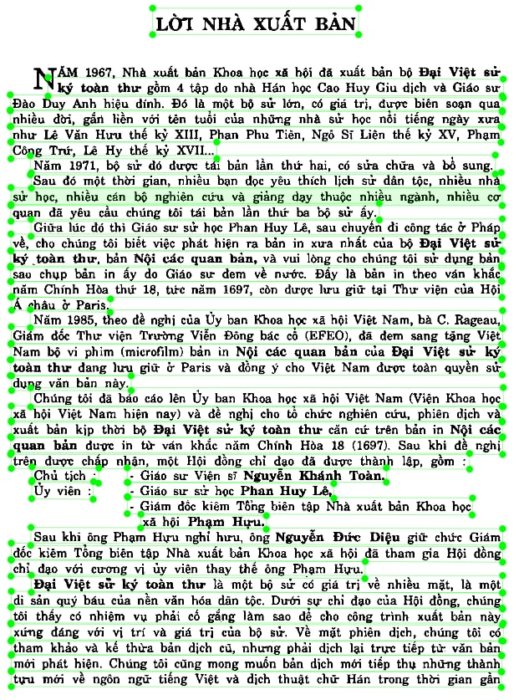
- Detection (Layout Analysis):
  - Segmentation: The model performed excellent segmentation of the document's structure. The main title, "LỜI NHÀ XUẤT BẢN," was correctly isolated in its own bounding box. Each paragraph was also accurately encapsulated within a distinct, tightly-bound box.
  - Accuracy: There were no observed instances of merged or split paragraphs, nor were any text areas missed. The granularity of detection is perfect, separating logical blocks of text as intended. The margins and line spacing are generous, which likely aided the layout analysis engine.
- Recognition (Text Transcription):
  - Accuracy: The character-level accuracy is near-perfect. The OCR engine demonstrated a strong capability in recognizing Vietnamese characters, including the full range of diacritics (e.g.., â, ư, ơ, đ) and tones (e.g..,á, à, ả, ã, ạ).
  - Specifics: Proper nouns ("Phan Phu Tiên," "Ngô Sĩ Liên") and Roman numerals (XIII, XV, XVII) appear to be transcribed correctly, indicating a robust and well-trained model.
- Potential Issues & Robustness Check:
  - Given the high quality of the input, the tool faced minimal challenges. On a lower-quality scan, potential issues could have included:
    - Confusion between similar characters (e.g., 'l' and 'i').
    - Missed or incorrect diacritics if the print were faint.
    - Merging of lines if the document were skewed.

Page 2 Evaluation
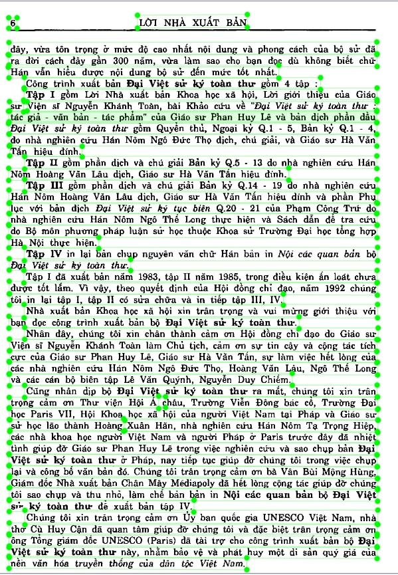
- Detection (Layout Analysis):
  - Structure Handling: This page contains a list-like structure (e.g., "Tập I," "Tập II," etc.). The detection algorithm successfully handled this by creating separate bounding boxes for each major point in the list, preserving the document's logical flow.
  - Consistency: The performance is consistent with Page 1. All paragraphs and headings are correctly identified without overlap or omission.
- Recognition (Text Transcription):
  - Data Recognition: The model accurately transcribed text containing a mix of letters, numbers, and symbols, such as "Q.1 - 4" and "Q.5." This demonstrates its ability to handle varied data types within a single text block.
  - Fidelity: The transcription fidelity remains extremely high. The names of historical figures and publications are recognized without apparent error.
- Potential Issues & Robustness Check:
  - The hyphen in "Q.1 - 4" could be a point of failure in less ideal conditions; it might be ignored or misread as noise.
  - The close proximity of the paragraph number (e.g., "6") to the start of the text was handled well here, but could potentially be merged or misinterpreted in other scenarios.

Page 3 Evaluation
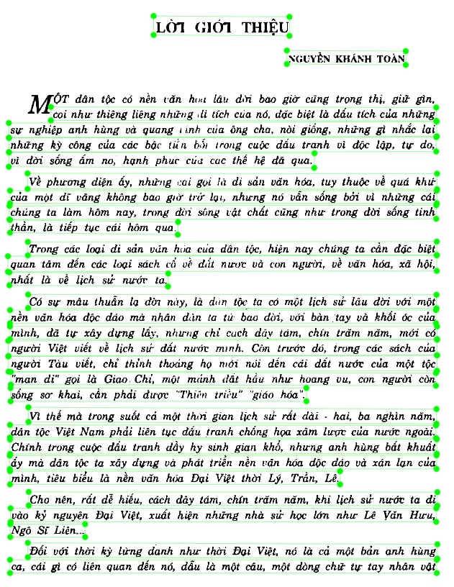
- Detection (Layout Analysis):
  - Complex Layout: This page features a more complex layout with a centered title ("LỜI GIỚI THIỆU"), a right-aligned author name ("NGUYỄN KHÁNH TOÀN"), and justified paragraphs. The tool correctly handled all these different alignments, creating separate, accurate boxes for each element.
  - Drop Cap Handling: Notably, the model successfully processed the large drop cap 'M' at the beginning of the first paragraph. It correctly included the 'M' within the bounding box of the paragraph instead of isolating it as a separate, erroneous object. This indicates a sophisticated layout analysis capability.
- Recognition (Text Transcription):
  - Font Invariance: The large size and slightly different styling of the drop cap 'M' did not confuse the recognition engine, which correctly transcribed the first word.
  - Consistency: The accuracy for the rest of the text remains at the same high standard seen on previous pages.
- Potential Issues & Robustness Check:
  - Drop caps are a classic challenge for OCR systems. A less advanced tool might have failed to recognize the 'M' or created a separate box for it, breaking the word "Một." The successful handling here is a strong positive indicator of the model's quality.

Page 4 Evaluation
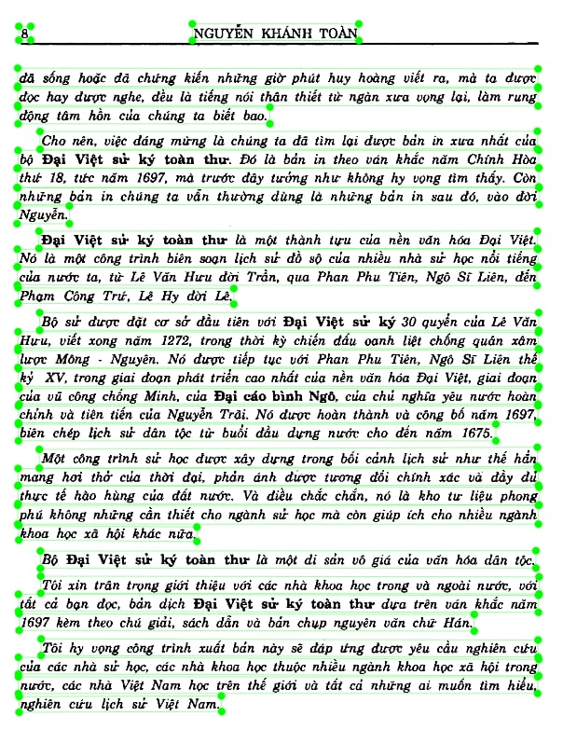
- Detection (Layout Analysis):
  - Standard Performance: The detection on this page is flawless and consistent with the others. The author's name at the top is cleanly separated from the main body of text, and each paragraph is perfectly boxed.
  - Whitespace Management: The tool effectively uses the large vertical whitespace between paragraphs to ensure proper segmentation.
- Recognition (Text Transcription):
  - Terminology and Dates: The OCR engine proves its robustness by accurately transcribing long, specific historical terms like "Đại Việt sử ký toàn thư" and "Đại cáo bình Ngô." It also correctly recognized all numerical dates ("1697," "1675").
  - Overall Quality: There are no observable recognition errors on this page. The output appears ready for use with minimal to no post-processing.
- Potential Issues & Robustness Check:
  - This page presents the fewest challenges. The only potential for error would come from external factors like image blur, low contrast, or artifacts from the scanning process, none of which are present in the provided image.

